DATA BASE SQL QUERING

SELECT A SPECIFIC DATABASE:

Format: use DataBasename;

*Sample Query:* **use AdventureWorks2012**

-----------------------------------------------------------------------------------------------------------------------------------

SELECT ALL VALUE FROM A TABLE:

Format: SELECT * FROM tablename;

*Sample Query*: **SELECT * FROM HumanResources.Department**

-----------------------------------------------------------------------------------------------------------------------------------

SHOW ME ALL THE DEPARTMENT NAMES.

Format: SELECT columnname FROM tablename;

*Sample Query*: **SELECT NAME FROM HumanResources.Department**

-----------------------------------------------------------------------------------------------------------------------------------

SHOW ME ALL THE GROUP.

Format: SELECT columnname FROM tablename;

*Sample Query*: **SELECT GROUPNAME FROM HumanResources.Department**

-----------------------------------------------------------------------------------------------------------------------------------

SHOW ME ALL THE DISTINCT GROUPNAME

Format: SELECT DISTINCT columnname FROM tablename;

*Sample Query*: **SELECT DISTINCT GROUPNAME FROM HumanResources.Department**

-----------------------------------------------------------------------------------------------------------------------------------

SHOW ME ALL THE DEPARTMENT NAME WHO ARE A PART OF MANUFACTURING

Format: SELECT columnname FROM tablename WHERE columnname like ’VALUE’;

*Sample Query*: **SELECT NAME, GROUPNAME FROM HumanResources.Department**

**WHERE GROUPNAME LIKE 'MANUFACTURING'**

-----------------------------------------------------------------------------------------------------------------------------------

GIVE ME ALL THE EMPLOYEES FROM THE EMPLOYEE TABLE

Format: SELECT * FROM tablename;

*Sample Query*: **SELECT * FROM HumanResources.Employee**

-----------------------------------------------------------------------------------------------------------------------------------

GIVE ME A LIST OF ALL EMPLOYEE WHO HAVE ORGLEVEL = 2

Format: SELECT * FROM tablename WHERE columnvalue = ’VALUE’;

*Sample Query*: **SELECT * FROM HumanResources.Employee WHERE ORGANIZATIONLEVEL = 2**

-----------------------------------------------------------------------------------------------------------------------------------

GIVE ME A LIST OF ALL EMPLOYEES WHO HAVE ORGLEVEL = 2 or 3

Format: SELECT * FROM tablename WHERE columnvalue IN (VALUE1,VALUE2);

*Sample Query*: **SELECT * FROM HumanResources.Employee WHERE ORGANIZATIONLEVEL IN (2,3)**

-----------------------------------------------------------------------------------------------------------------------------------

GIVE ME A LIST OF EMPLOYEES WHO HAVE A TITLE AS FACILITIES MANAGER

Format: SELECT columnname FROM tablename WHERE columnname like ’VALUE’;

*Sample Query*:

**SELECT * FROM HumanResources.Employee WHERE JOBTITLE LIKE 'FACILITIES MANAGER'**

-----------------------------------------------------------------------------------------------------------------------------------

GIVE ME ALL THE EMPLOYEES WHO HAVE THE WORD MANAGER IN THEIR TITLE

Format: SELECT columnname FROM tablename WHERE columnname like ’%VALUE%’;

*Sample Query*:

**SELECT * FROM HumanResources.Employee WHERE JOBTITLE LIKE '%Manager%'**

-----------------------------------------------------------------------------------------------------------------------------------

GIVE ME ALL EMPLOYEE WHO ARE BORN AFTER Jan 1 , 1980

Format: SELECT * FROM tablename WHERE columnname > ’VALUE’;

*Sample Query*:

**SELECT * FROM HumanResources.Employee WHERE Birthdate > '1/1/1980'**

-----------------------------------------------------------------------------------------------------------------------------------

GIVE ME ALL EMPLOYEES WHO ARE BORN BETWEEN Jan1 , 1970 and Jan1 , 1980

Format:

SELECT * FROM tablename WHERE columnname > ’VALUE1’ AND columnname < ’VALUE2’;

*Sample Query*:

**SELECT * FROM HumanResources.Employee WHERE BirthDate > '1/1/1970' AND BirthDate < '1/1/1980'**

Format: SELECT * FROM tablename WHERE columnname BETWEEN ’VALUE’ AND ’VALUE2’;

*Sample Query*:

**SELECT * FROM HumanResources.Employee WHERE BirthDate BETWEEN '1/1/1970' AND '1/1/1980'**

-----------------------------------------------------------------------------------------------------------------------------------

DELETE DATA FROM TABLE

Format: DELETE * FROM tablename WHERE name LIKE ’VALUE’;

*Sample Query*:

**DELETE FROM Production.Product_2 WHERE NAME LIKE 'Bearing Ball'**

-----------------------------------------------------------------------------------------------------------------------------------

UPDATE DATA FROM TABLE

Format: UPDATE tablename SET name = ‘NEWVALUE’ WHERE name LIKE ’OLDVALUE’;

*Sample Query*:

**UPDATE Production.Product_2 SET NAME = 'BLADE_NEW' WHERE NAME LIKE 'BLADE'**

-----------------------------------------------------------------------------------------------------------------------------------

SELECT SELECTTOPNROWS DATA FROM TABLE

Format: SELECT TOP (N_Values) * FROM tablename WHERE name LIKE ’OLDVALUE’;

*Sample Query*:

**SELECT top 10 * FROM AdventureWorks2012.Production.WorkOrder**

-----------------------------------------------------------------------------------------------------------------------------------

CREATE TABLE

Format: CREATE TABLE tablename (columnname1 DataType1(MaxValue), columnname2 DataType2(MaxValue), columnname3 DataType3(MaxValue));

*Sample Query*:

**CREATE TABLE MYEMPLOYEE (EMPLOYEEID INT, FIRSTNAME VARCHAR(20), LASTNAME VARCHAR(20))**

**CREATE TABLE MYSALARY (EMPLOYEEID INT, SALARY FLOAT)**

------------------------------------------------------------------------------------------------------------------------------------------

CREATE TABLE

Format: INSERT INTO tablename VALUES(Value1,Value2,Value3);

*Sample Query*:

**INSERT INTO MYEMPLOYEE VALUES (1, 'Michael', 'Scott')**

**INSERT INTO MYEMPLOYEE VALUES (2, 'Pam', 'Beesly')**

**INSERT INTO MYEMPLOYEE VALUES (3, 'Dwight', 'Schutte')**

**INSERT INTO MYSALARY VALUES (1, 10000)**

**INSERT INTO MYSALARY VALUES (2, 8000)**

**INSERT INTO MYSALARY VALUES (3, 6000)**

**SELECT * FROM MYSALARY**

**SELECT * FROM MYEMPLOYEE**

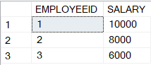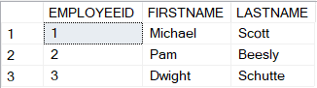

------------------------------------------------------------------------------------------------------------------------------------------

DROP(DELETE TABLE)/TRUNCATE(REMOVE VALUES) TABLE MYEMPLOYEE

Format: TRUNCATE TABLE tablename;

*Sample Query*: **TRUNCATE TABLE MYEMPLOYEE**

Format: DROP columnname FROM tablename;

*Sample Query*: **DELETE employeename FROM MYEMPLOYEE**

------------------------------------------------------------------------------------------------------------------------------------------

**-----------------------------------------------------------------------------------------------------------------------------------**

**JOINS.**

**-----------------------------------------------------------------------------------------------------------------------------------**

*INNER JOIN*

Format: SELECT obj1.columnname,obj2 columnname. FROM tablename1 obj1 INNER JOIN tablename2 obj2 ON’ obj1.columnvalue = obj2.columnvalue’;

*Sample Query*:

**SELECT A.FIRSTNAME, A.LASTNAME, B.SALARY FROM MYEMPLOYEE A INNER JOIN MYSALARY B**

**ON A.EMPLOYEEID = B.EMPLOYEEID**

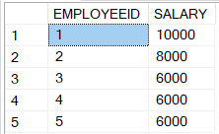

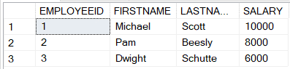

-----------------------------------------------------------------------------------------------------------------------------------

*OUTER JOIN:*

1. *LEFT OUTER JOIN*

Format: SELECT obj1.columnname,obj2 columnname. FROM tablename1 obj1 LEFT JOIN tablename2 obj2 ON’ obj1.columnvalue = obj2.columnvalue’;

*Sample Query*:

**CREATE TABLE MYPHONE (EMPLOYEEID INT, PHONNENUMBER INT)**

**INSERT INTO MYPHONE VALUES (1, 1211123342)**

**INSERT INTO MYPHONE VALUES (2, 1111111111)**

**SELECT * FROM MYEMPLOYEE**

**SELECT * FROM MYPHONE**

**SELECT B.EMPLOYEEID,B.PHONNENUMBER,A.FIRSTNAME,A.LASTNAME FROM MYEMPLOYEE A LEFT JOIN MYPHONE B ON A.EMPLOYEEID = B.EMPLOYEEID;**

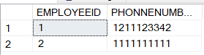

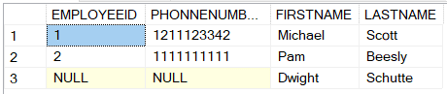

1. *RIGHT OUTER JOIN*

Format: SELECT obj1.columnname,obj2 columnname. FROM tablename1 obj1 OUTER JOIN tablename2 obj2 ON’ obj1.columnvalue = obj2.columnvalue’;

*Sample Query*:

**CREATE TABLE MYPARKING (EMPLOYEEID INT, PARKINGSPOT VARCHAR(20))**

**INSERT INTO MYPARKING VALUES (1, 'A1')**

**INSERT INTO MYPARKING VALUES (2, 'A2')**

**SELECT * FROM MYPARKING**

**SELECT * FROM MYEMPLOYEE**

**SELECT A.PARKINGSPOT, B.FIRSTNAME, B.LASTNAME FROM MYPARKING A RIGHT JOIN MYEMPLOYEE B ON A.EMPLOYEEID = B.EMPLOYEEID**

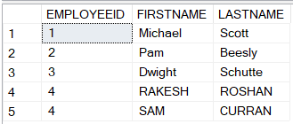 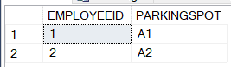

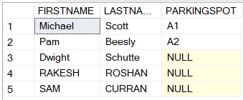

1. *FULL OUTER JOIN*

Format: SELECT obj1.columnname,obj2 columnname. FROM tablename1 obj1 OUTER JOIN tablename2 obj2 ON’ obj1.columnvalue = obj2.columnvalue’;

*Sample Query*:

**CREATE TABLE MYCUSTOMER(CUSTOMERID INT, CUSTOMERNAME VARCHAR(20))**

**INSERT INTO MYCUSTOMER VALUES (1, 'RAKESH')**

**INSERT INTO MYCUSTOMER VALUES (3, 'JOHN')**

**CREATE TABLE MYORDER (ORDERNUMBER INT, ORDERNAME VARCHAR(20), CUSTOMERID INT)**

**INSERT INTO MYORDER VALUES (1, 'SOMEORDER1', 1)**

**INSERT INTO MYORDER VALUES (2, 'SOMEORDER2', 2)**

**INSERT INTO MYORDER VALUES (3, 'SOMEORDER3', 7)**

**INSERT INTO MYORDER VALUES (4, 'SOMEORDER4', 8)**

**SELECT * FROM MYCUSTOMER**

**SELECT * FROM MYORDER**

**SELECT A.CUSTOMERID, A.CUSTOMERNAME, B.ORDERNUMBER, B.ORDERNAME, B.ORDERNAME**

**FROM MYCUSTOMER A FULL OUTER JOIN MYORDER B ON A.CUSTOMERID = B.CUSTOMERID**

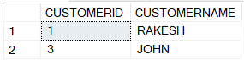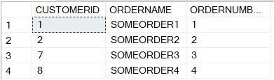

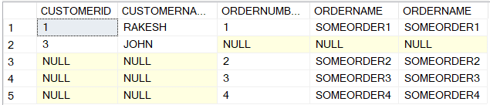

-----------------------------------------------------------------------------------------------------------------------------------

*CROSS JOIN*

Format: SELECT * FROM tablename1 CROSS JOIN tablename2 obj2

*Sample Query*:

**SELECT * FROM MYEMPLOYEE**

**SELECT * FROM MYSALARY**

**SELECT * FROM MYEMPLOYEE CROSS JOIN MYSALARY**

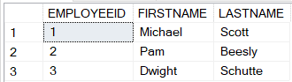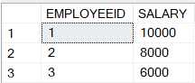

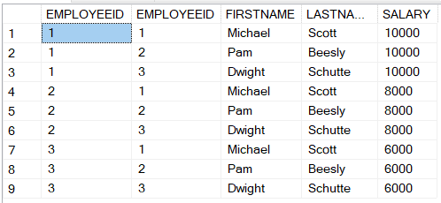

-----------------------------------------------------------------------------------------------------------------------------------

**-----------------------------------------------------------------------------------------------------------------------------------**

**DATE FUNCTIONS.**

**-----------------------------------------------------------------------------------------------------------------------------------**

GET CURRENT DATE - ENTIREDATE

Format: SELECT GETDATE();

*Sample Query*:

**SELECT GETDATE();**

-----------------------------------------------------------------------------------------------------------------------------------

GET DAY BEFORE YESTERDAYS DATE (CURRENTDATE – 2 DAYS)

Format: SELECT GETDATE() – NoofDaystobeRemoved/INT;

*Sample Query*:

**SELECT GETDATE() - 2**

-----------------------------------------------------------------------------------------------------------------------------------

GET CURRENT DATE IN A SPECIFIC FORMAT-DAY/MONTH/YEAR -ENTIREDATE

Format: SELECT DATEPART(format,’datetobeformated’);

*Sample Query*:

**SELECT DATEPART(yyyy, GETDATE())**

**SELECT DATEPART(dd, GETDATE())**

**SELECT DATEPART(mm, GETDATE())**

-----------------------------------------------------------------------------------------------------------------------------------

ADD & GET DAYS/MONTH/YEAR TO CURRENT DATE

Format:

SELECT DATEADD(formattowhichvaluehastobeadded,value ,’datetobeformated’);

*Sample Query*:

**SELECT DATEADD(day, 4, GETDATE())**

**SELECT DATEADD(month, 4, GETDATE())**

**SELECT DATEADD(year, 4, GETDATE())**

-----------------------------------------------------------------------------------------------------------------------------------

GET DIFFERENCE OF DAY/MONTH/YEAR BETWEEN TWO DATES

Format: SELECT DATEADD(format-valuewhichvaluehastobeRetrieved,’fromdate’ ,’todate’);

*Sample Query*:

**SELECT DATEDIFF(day, '6/1/2015', GETDATE())**

**SELECT DATEDIFF(month, '6/1/2015', GETDATE())**

**SELECT DATEDIFF(month, '4/1/2015', GETDATE())**

**SELECT DATEDIFF(year, '6/1/2014', GETDATE())**

**SELECT WorkOrderID, ProductID, StartDate, EndDate, DATEDIFF(day, StartDate, EndDate)**

**FROM AdventureWorks2012.Production.WorkOrder**

-----------------------------------------------------------------------------------------------------------------------------------

GET THE FIRST DAY OF THIS MONTH

Format: SELECT (DATEADD(formattowhichvaluehastobeadded,value ,’datetobeformated’);

*Sample Query*:

**SELECT (DATEADD(dd, -(DATEPART(day, GETDATE()) - 1), GETDATE()))**

-----------------------------------------------------------------------------------------------------------------------------------

**-----------------------------------------------------------------------------------------------------------------------------------**

**AGGREGATE FUNCTIONS.**

**-----------------------------------------------------------------------------------------------------------------------------------**

GET THE AVERAGE OF A COLUMN

Format: SELECT AVG(columnname) FROM tablename

*Sample Query*:

**SELECT AVG(SALARY) FROM MYSALARY**

-----------------------------------------------------------------------------------------------------------------------------------

GET THE COUNT OF A COLUMN

Format: SELECT COUNT(columnname) FROM tablename

*Sample Query*: **SELECT COUNT(SALARY) FROM MYSALARY**

Format: SELECT COUNT(*) FROM tablename

*Sample Query*: **SELECT COUNT(*) FROM MYSALARY**

-----------------------------------------------------------------------------------------------------------------------------------

GET THE SUM OF A COLUMN

Format: SELECT SUM(columnname) FROM tablename

*Sample Query*:

**SELECT SUM(SALARY) FROM MYSALARY**

-----------------------------------------------------------------------------------------------------------------------------------

GET THE MAX OF A COLUMN

Format: SELECT MAX(columnname) FROM tablename

*Sample Query*:

**SELECT MAX(SALARY) FROM MYSALARY**

----------------------------------------------------------------------------------------------------------------------------------

GET THE MIN OF A COLUMN

Format: SELECT MIN(columnname) FROM tablename

*Sample Query*:

**SELECT MIN(SALARY) FROM MYSALARY**

-----------------------------------------------------------------------------------------------------------------------------------

**-----------------------------------------------------------------------------------------------------------------------------------**

**STRING FUNCTIONS.**

**-----------------------------------------------------------------------------------------------------------------------------------**

CONCAT AND GET TWO COLUMNS INTO A NEW COLUMN

Format:

SELECT columnName1,columnName2 CONCAT (columnName1, “ “, columnName2 )AS concatenatedtablename

*Sample Query*:

**SELECT ORDERNUMBER, ORDERNAME, CONCAT(ORDERNAME, ' ' , ORDERNAME) AS CONCATENATEDTEXT FROM MYORDER**

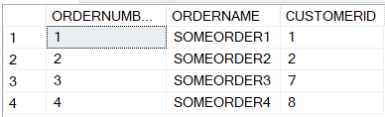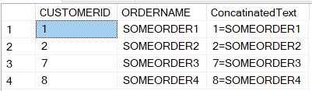

-----------------------------------------------------------------------------------------------------------------------------------

GENERATE & GET RANDOM NUMBER AND CONCATENATE TO A STRING

Format:

SELECT columnname CONCAT (columnName, RAND(noofdigits)AS concatenatedtablename

*Sample Query*:

**SELECT ORDERNUMBER, ORDERNAME, CONCAT(ORDERNAME, ‘-‘ , RAND(5)) AS CONCATENATEDTEXT FROM MYORDER**

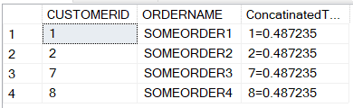

-----------------------------------------------------------------------------------------------------------------------------------

LEFT SPLIT & GET A STRING

Format: SELECT columnname, LEFT(columnName,noofcharacterfromleft) FROM tablename

*Sample Query*: **SELECT ORDERNUMBER, ORDERNAME, LEFT(ORDERNAME, 5) FROM MYORDER**

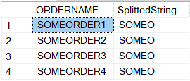

-----------------------------------------------------------------------------------------------------------------------------------

RIGHT SPLIT & GET A STRING

Format: SELECT columnname, RIGHT(columnName, noofcharacterfromright) FROM tablename

*Sample Query*: **SELECT ORDERNUMBER, ORDERNAME, RIGHT(ORDERNAME, 5) FROM MYORDER**

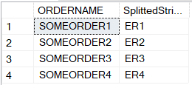

-----------------------------------------------------------------------------------------------------------------------------------

GET SUBSTRING FROM A STRING

Format: SELECT columnname, SUBSTRING (columnName,noofcharacterfromleft, noofcharacterfromright ) FROM tablename

*Sample Query*: **SELECT ORDERNUMBER, ORDERNAME, SUBSTRING(ORDERNAME, 2, 5) FROM MYORDER**

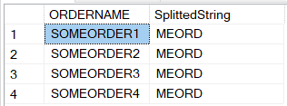

-----------------------------------------------------------------------------------------------------------------------------------

CONVERT & GET A STRING AS LOWERCASE

Format:

SELECT columnname, LOWER (columnName) FROM tablename

*Sample Query*: **SELECT ORDERNUMBER, ORDERNAME, LOWER(ORDERNAME) FROM MYORDER**

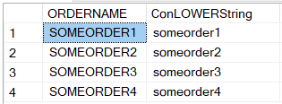

-----------------------------------------------------------------------------------------------------------------------------------

CONVERT & GET A STRING AS UPPERCASE

Format:

SELECT columnname, UPPER (columnName) FROM tablename

*Sample Query*: **SELECT ORDERNUMBER, ORDERNAME, UPPER (ORDERNAME) FROM MYORDER**

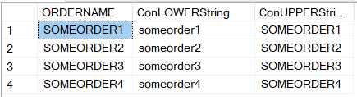

-----------------------------------------------------------------------------------------------------------------------------------

LENGHT OF STRING

Format:

SELECT columnname, LEN (columnName) FROM tablename

*Sample Query*:

**SELECT ORDERNUMBER, ORDERNAME, LEN(ORDERNAME) FROM MYORDER**

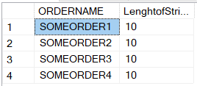

-----------------------------------------------------------------------------------------------------------------------------------

LEFT TRIM & GET A STRING

Format: SELECT LTRIM(columnName/String)

*Sample Query*: **SELECT LTRIM(' MyText')**

-----------------------------------------------------------------------------------------------------------------------------------

RIGHT TRIM & GET A STRING

Format: SELECT RTRIM(columnName/String)

*Sample Query*: **SELECT RTRIM('MyText ')**

-----------------------------------------------------------------------------------------------------------------------------------

GROUP ROWS THAT HAVE THE SAME VALUES INTO SUMMARY ROWS

Format: SELECT columnName FROM tablename GROUP BY columnName;

*Sample Query*: **SELECT COUNT(Customer), Country FROM Customers GROUP BY Country;**

-----------------------------------------------------------------------------------------------------------------------------------

GET LIST OF RECORDS IN AN ALPHABETICAL ORDER

Format: SELECT columnName FROM tablename ORDER BY columnName;

*Sample Query*: **SELECT * FROM Customers ORDER BY Country;**

-----------------------------------------------------------------------------------------------------------------------------------

**-----------------------------------------------------------------------------------------------------------------------------------**

**CALCULATED COLUMNS.**

**-----------------------------------------------------------------------------------------------------------------------------------**

AS FUNCTION( ALIAS FUNNCTION)

Format:

SELECT columnname1,columnname2, columnname +10 AS NewcolumnName FROM tablename

*Sample Query*:

**SELECT NAME, LISTPRICE FROM Production.Product**

**SELECT NAME, LISTPRICE, LISTPRICE + 10 AS ADJUSTED_LIST_PRICE FROM Production.Product**

-----------------------------------------------------------------------------------------------------------------------------------

INTO FUNCTION

1.PERMANENT TABLE

Format: SELECT columnname1,columnname2, columnname +10 AS NewcolumnName INTO newparmanenttablename FROM tablename

*Sample Query*: **SELECT NAME, LISTPRICE, LISTPRICE + 10 AS ADJUSTED_LIST_PRICE INTO Production.Product_2 FROM Production.Product**



**SELECT * FROM Production.Product_2**

2.TEMPARORY TABLE

Format:

SELECT columnname1,columnname2, columnname +10 AS NewcolumnName INTO #newtemporarytablename FROM tablename

*Sample Query*:

**SELECT NAME, LISTPRICE, LISTPRICE + 10 AS ADJUSTED_LIST_PRICE INTO #tmpname FROM Production.Product**



**SELECT * FROM #tmpname**

-----------------------------------------------------------------------------------------------------------------------------------